# *Lab manual 8*

## Home tasks:

## Name: Muhammad Usman Bhutto.

## Roll no: 453891

## Section: B

## Home task 1:

#include<iostream>

using namespace std;

int main()

{

int n;

cout<<"enter number of elements:";

cin>>n;

int arr[n];

cout<<"enter elements:";

for(int i=0;i<n;i++){

cin>>arr[i];

}

cout<<"Repeating elements are:";

for(int i=0;i<n;i++){

for(int j=i+1;j<n;j++){

if(arr[i]==arr[j]){

cout<<arr[j]<<" ";

}

}

}

return 0;

}

## Output:

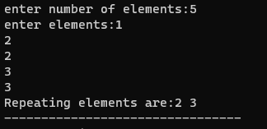

## Home task 2:

#include<iostream>

using namespace std;

int main()

{

int arr[8]={13,15,17,9,99,77,65,43};

int n=8;

for(int i=0;i<n-1;i++){

for(int j=0;j<n-i-1;j++){

if(arr[j]>arr[j+1]){

int temp=arr[j+1];

arr[j+1]=arr[j];

arr[j]=temp;

}

}

}

cout<<"smallest element in the array is:"<<" ";

for(int i=0;i<1;i++){

cout<<arr[0]<<endl;

}

cout<<"largest element in the array is:"<<" ";

for(int i=0;i<1;i++){

cout<<arr[7]<<endl;

}

return 0;

}

## Output:

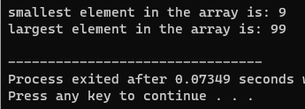

## Home task 3:

#include<iostream>

using namespace std;

int main()

{

int n;

cout<<"enter the number of elements:";

cin>>n;

int arr[n];

cout<<"enter elements:";

for(int i=0;i<n;i++)

cin>>arr[i];

cout<<"original array:";

for(int i=0;i<n;i++)

cout<<arr[i]<<" ";

cout<<"\n array after swapping:";

for(int i=0;i<n;i++){

int temp=arr[2];

arr[2]=arr[4];

arr[4]=temp;

cout<<arr[i]<<" ";

}

return 0;

}

## Output:

